Name: Date of Birth: Date of Service:

Have you been experiencing any of the following symptoms?
Yes / No Yes/No Yes/No
❒❒ Fever, chills ❒❒ Shortness of breath ❒❒ Constipation
❒❒ Wt. ❒loss ❒ gain >10lbs ❒❒ Weakness in ❒arms ❒legs ❒❒ High blood sugars
❒❒ Blurry vision ❒❒ Numbness in ❒arms ❒legs ❒❒ Easy bruising
❒❒ Decreased hearing ❒❒ Problems walking or recent falls ❒❒ Swollen glands
❒❒ Sore throat ❒❒ Stomach pain or nausea ❒❒ Depression
❒❒ Chest pain or palpitations ❒❒ Bowel or bladder incontinence ❒❒ Anxiety
❒❒ Allergies? To what? ________________________________________ ❒❒ New rash or lesion
Allergic to: ❒Iodine or IV contrast ❒ Latex

Have you tried any of the following therapies?
Yes / No Yes / No
❒❒ Physical therapy ❒❒ Chiropractic manipulation
❒❒ Pool therapy ❒❒ Back or neck surgery
❒❒ TENS therapy ❒❒ Injections (Epidurals, facet blocks, joint injections, etc.)
❒❒ Acupuncture ❒❒ Pain management counseling or psychiatric therapy
❒❒ Opiate analgesics ❒❒ Non-opiate analgesics ‘
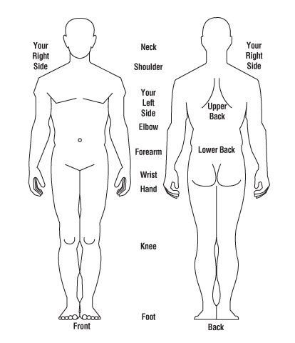
Where is your worst pain? On the diagram to the right, shade in the areas(s) that are painful.
❒Lower Back ❒Mid-back ❒Neck ❒Shoulder ❒Hip ❒Knee
Other:__________________________________

Quality of pain: ❒Aching ❒Throbbing ❒Shooting ❒Burning
❒Uncomfortable ❒Dull ❒Radiating ❒Sharp ❒Cramping

Timing of pain: ❒ Constant ❒ Intermittent

Average pain level WITH pain medication:
❒ 1 ❒ 2 ❒ 3 ❒ 4 ❒ 5 ❒ 6 ❒ 7 ❒ 8 ❒ 9 ❒ 10
Average pain level WITHOUT pain medication:
❒ 1 ❒ 2 ❒ 3 ❒ 4 ❒ 5 ❒ 6 ❒ 7 ❒ 8 ❒ 9 ❒ 10

WORST pain level :
❒ 1 ❒ 2 ❒ 3 ❒ 4 ❒ 5 ❒ 6 ❒ 7 ❒ 8 ❒ 9 ❒ 10
BEST pain level :
❒ 1 ❒ 2 ❒ 3 ❒ 4 ❒ 5 ❒ 6 ❒ 7 ❒ 8 ❒ 9 ❒ 10
Functionality: ❒ Limited due to pain ❒ Ambulation and activity of daily living is affected by pain
What makes your pain better: ❒ Rest ❒ Ice pack ❒ Heat ❒ Medication ❒ Exercise ❒ Stretching
What makes your pain worst: ❒ Sitting ❒ Bending ❒ Standing ❒ Lying down ❒ Lifting ❒ Walking

Are you having trouble sleeping due to pain? ❒ Yes ❒ No Do you Smoke? ❒ Yes ❒ No
Are you currently working? ❒ Yes ❒ No Are you using illegal street drugs? ❒ Yes ❒ No

What blood thinners are you taking? ❒NONE ❒COUMADIN ❒PLAVIX ❒PRADAXA ❒XARELTO
❒AGGRENOX ❒CILOSTAZOL ❒TICLID ❒EFFIENT ❒BRILINTA ❒APIXABAN ❒OTHER________________________________

Patient’s Signature:_________________________________________________ Date:____________________________

